Types of Verbs
# Source: AI Source: Provided by: [Data Path: Persons Table -> ID Column: 1, Name_En Column: Motasem Essam] -> From: [Chatgpt (GPT-4-turbo)] on [7/27/2025]
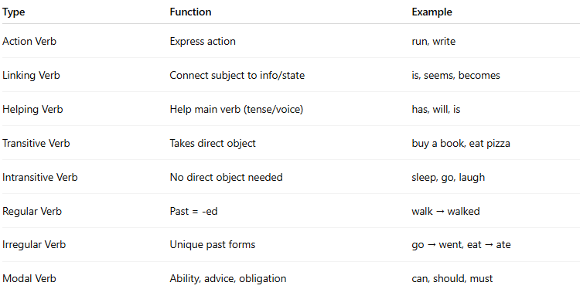

Type | Function | Example
Action Verb | Express action | run, write
Linking Verb | Connect subject to info/state | is, seems, becomes
Helping Verb | Help main verb (tense/voice) | has, will, is
Transitive Verb | Takes direct object | buy a book, eat pizza
Intransitive Verb | No direct object needed | sleep, go, laugh
Regular Verb | Past = -ed | walk → walked
Irregular Verb | Unique past forms | go → went, eat → ate
Modal Verb | Ability, advice, obligation | can, should, must

